**Praktikum Database**

**1.**

|  |
| --- |
| **select ename, sal**  **from emp**  **where sal>2850** |

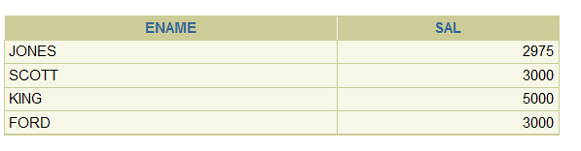

**2.**

|  |
| --- |
| **select ename, deptno**  **from emp**  **where empno=7566** |

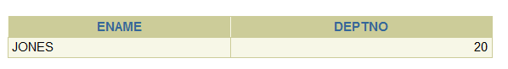

**3.**

|  |
| --- |
| **select ename,sal**  **from emp**  **where sal between 1500 and 2850** |

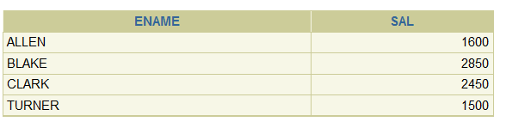

**4.**

|  |
| --- |
| **select ename, job, hiredate**  **from emp**  **where hiredate between '20-FEB-81' and '1-MAY-81'** |

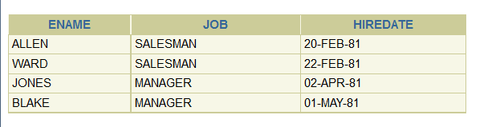

**5.**

|  |
| --- |
| **select ename, deptno**  **from emp**  **where deptno =10 or deptno =30** |

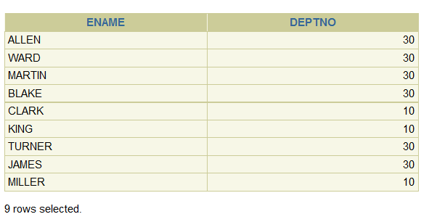

**6.**

|  |
| --- |
| **select ename as pegawai, sal as gaji_sebulan**  **from emp**  **where sal>1500** |

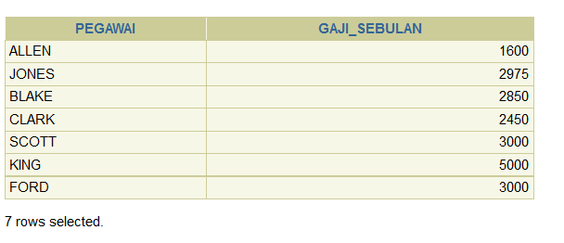

**7.**

|  |
| --- |
| **select ename,hiredate**  **from emp**  **where hiredate like '%82'** |

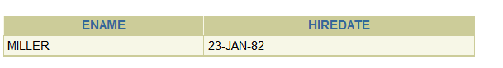

**8.**

|  |
| --- |
| **select ename, job**  **from emp**  **where mgr is null** |

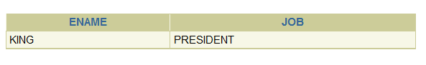

**9.**

|  |
| --- |
| **select ename, sal, comm**  **from emp**  **where comm is not null**  **order by sal desc,comm desc** |

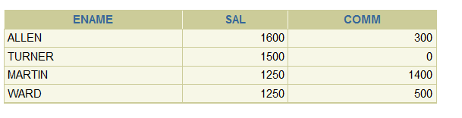

**10.**

|  |
| --- |
| **select ename**  **from emp**  **where substr(ename,3) like '%A%'** |

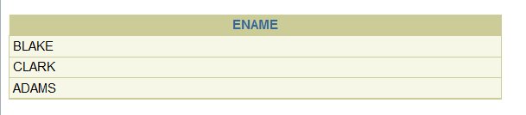

**11.**

|  |
| --- |
| **select ename**  **from emp**  **where ename like '%LL%'** |

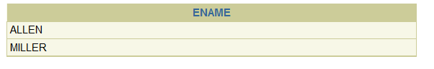

**12.**

|  |
| --- |
| **select ename, job, sal**  **from emp**  **where job ='CLERK' or job= 'ANALYST'** |

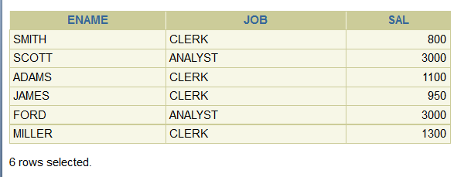

**13.**

|  |
| --- |
| **select ename, sal, comm**  **from emp**  **where comm>(sal+(sal*10/100))** |

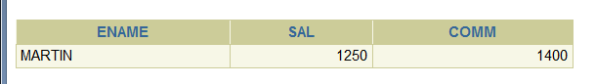

**Tambahan :**

|  |
| --- |
| **desc emp** |

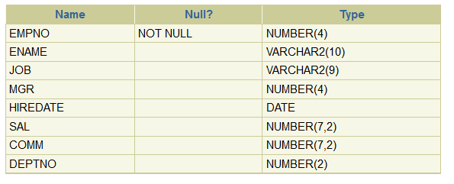

|  |
| --- |
| **select ename, nvl(comm, 0) from emp** |

